**Proposed Workflow Glossary**

**Transcription Factor Map View** (This view shows the transcription regulatory network without the genes. A node is a transcription factor (TF). The edges show regulation occurs between the two nodes with the direction of the arrow identifying which TF regulates the other TF.);

* (Highlighted pathway from TF Map)

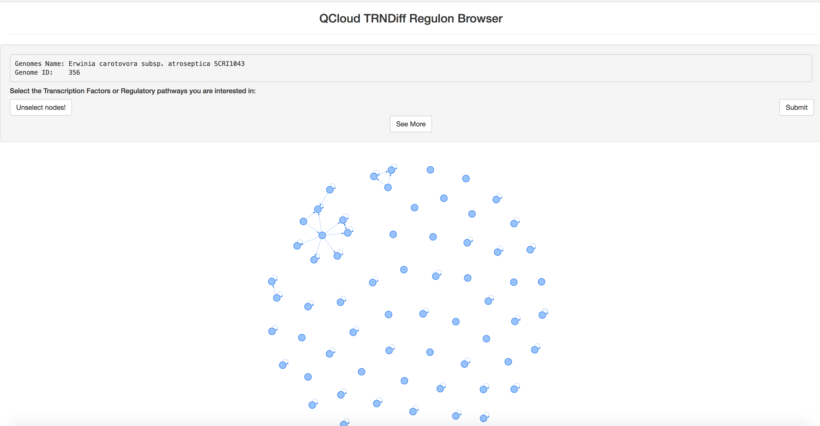

Filtered Out TF Map View with selected Pathway

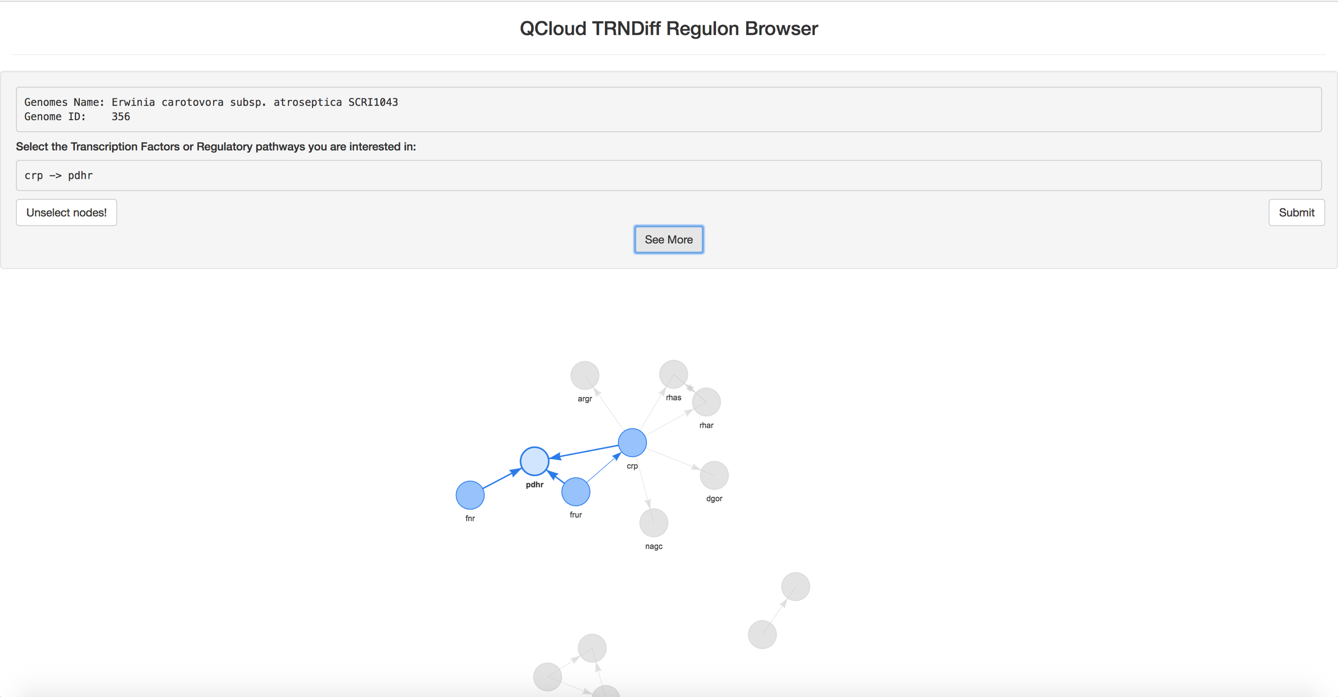

**Pathway Network View** (This shows the selected Transcription Factor Pathway expanded to include all the genes. Initially the page will show you this expanded view for your chosen genome however, you have the option to compare this pathway to all the other genomes that contain all of the TF you have selected in their network).

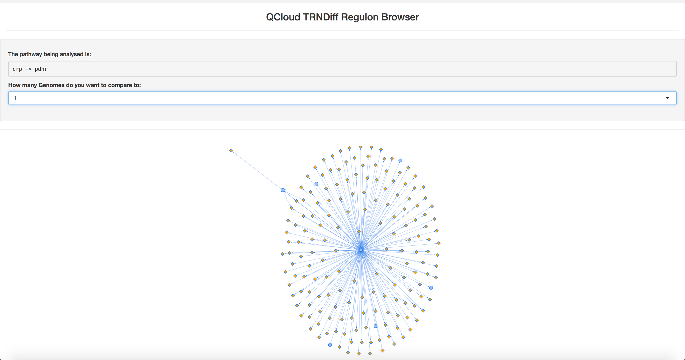

**Compare Pathway Network View** (This shows **pathway network view** across the genomes you would like to compare).

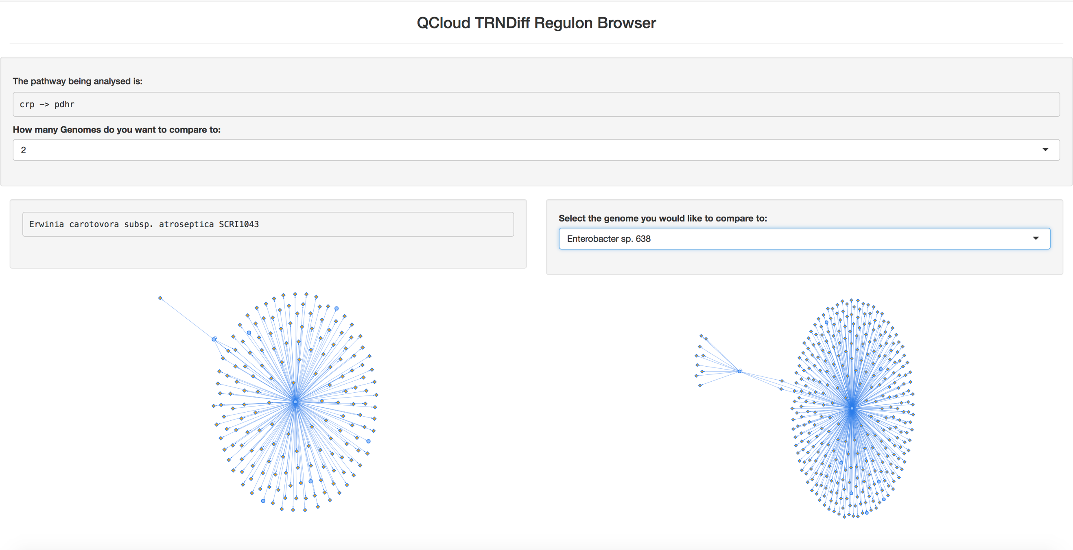

**View Regulon (**This is a current view in TRNDiff that shows wagon wheel representations of the selected Regulon you would like to explore across all the genomes in RegPrecise that contain that regulon. NOTE: if you upload your own data is will show all instances of the regulon in your local data).

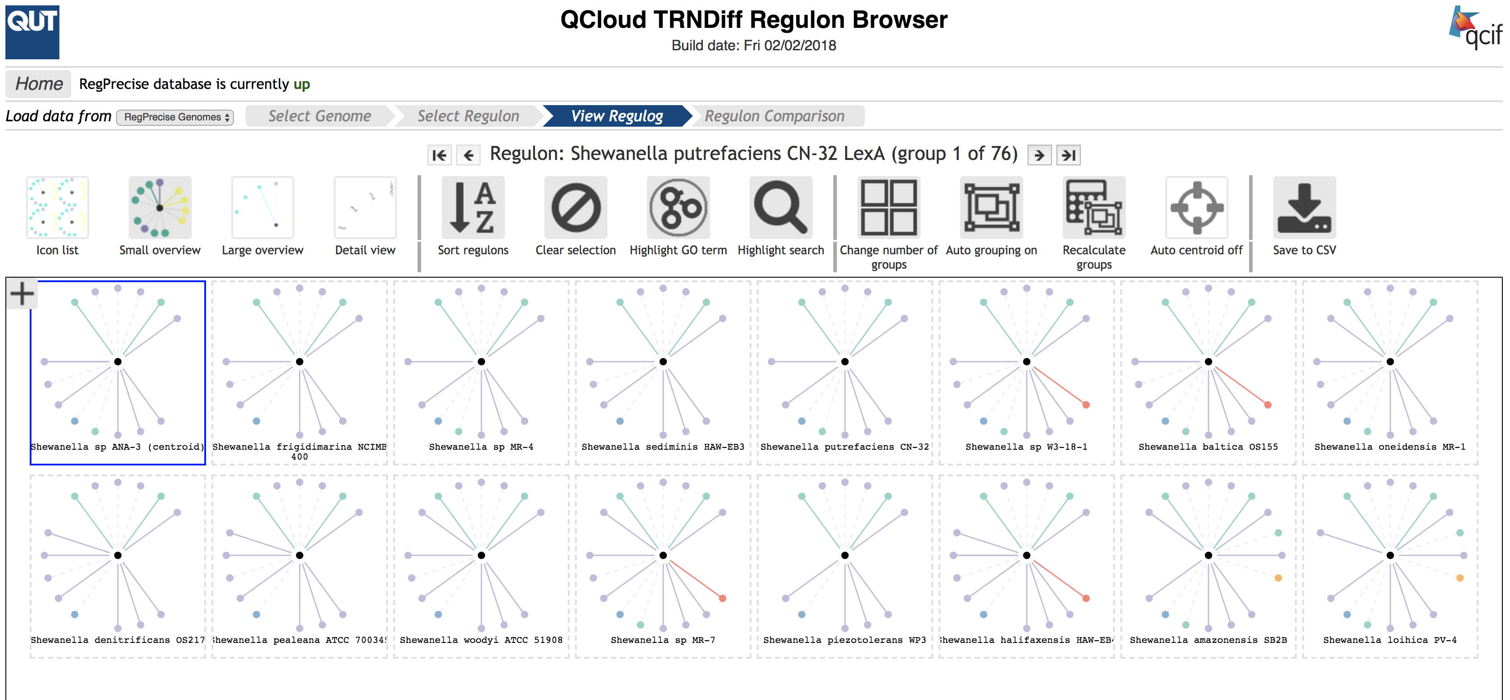

**Compare Regulon** (This is a current view in TRNDiff that allows the user to compare the selected regulon across two genomes. If has functionality such as XOR, OR & AND).

